LAB-3

a) Extend the Mobile Web Client Application you implemented in Lab 2 **with HTML5 Local Database.**

I have implemented HTML5 Local Database on my LAB2. I have stored the number of times the user has clicked on the application (no of clicks). After running the code in the jsfiddle, I have got the following results.

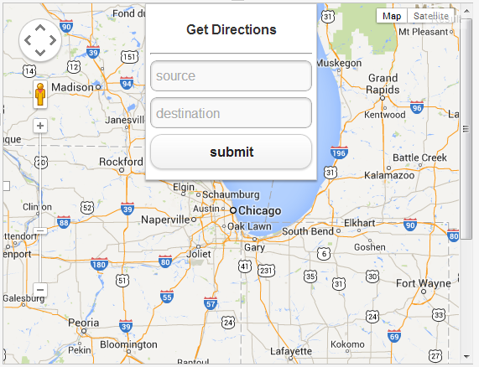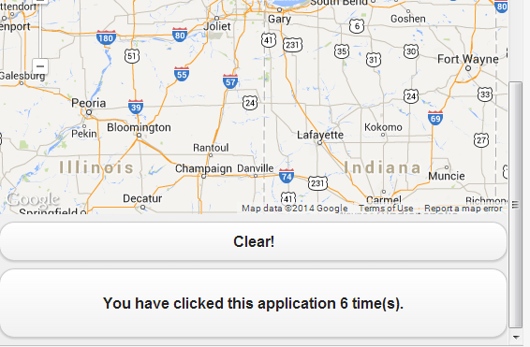

After clicking clear we will get a message that storage is cleared

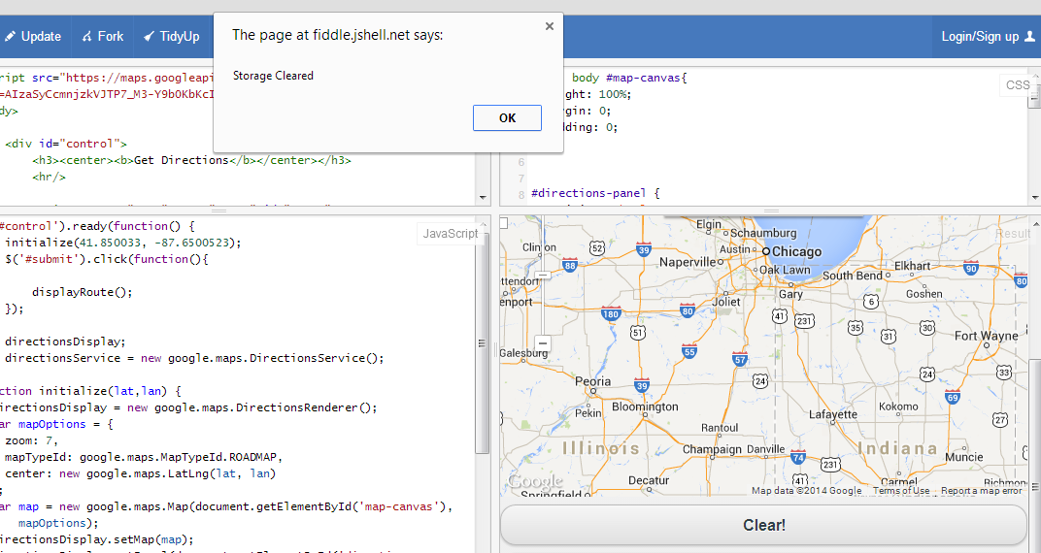

The storage register got cleared and we got the following output.

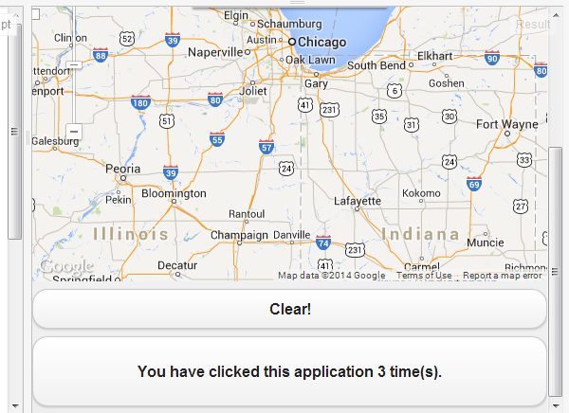

Ref: w3 schools HTML5

Jsfiddle output link: <http://jsfiddle.net/92jqK/7/>